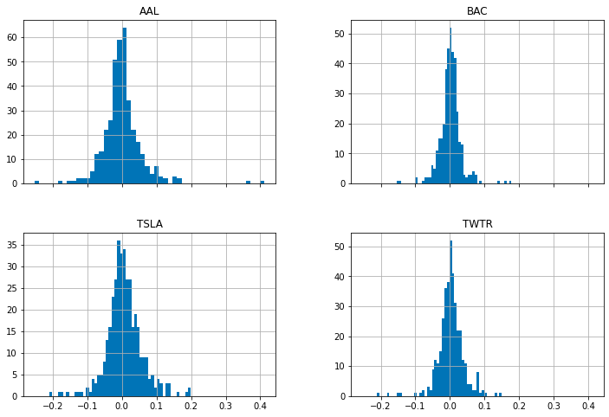

The 4 plots have the daily pct change on the y axis and how many times this occurred from January 2020 to June 2021 on the y axis. The x axis is a % change with 0.4 = 40%. I have plotted the 4 stocks American Airlines (AAL), Bank of America (BAC), Tesla (TSLA) and Twitter (TWTR).

From looking on the x axis we can see that for American airlines has a bigger range from -0.2 to 0.4 which means that the stock was more volatile during this time whereas the other stocks didn’t move more than 20% on a given day.

We can also see what stocks were more volatile by looking at the shape of the curve, the broader the curve is the more volatile the stock was in the given time period. From this we can see American Airlines is the most volatile, followed by Tesla, Twitter and finally Bank of America. Moreover we can observe Bank of America was more stable during this time vs the other stocks due to the fact it doesn’t reach past -20% on the x-axis whereas all the other stocks did.